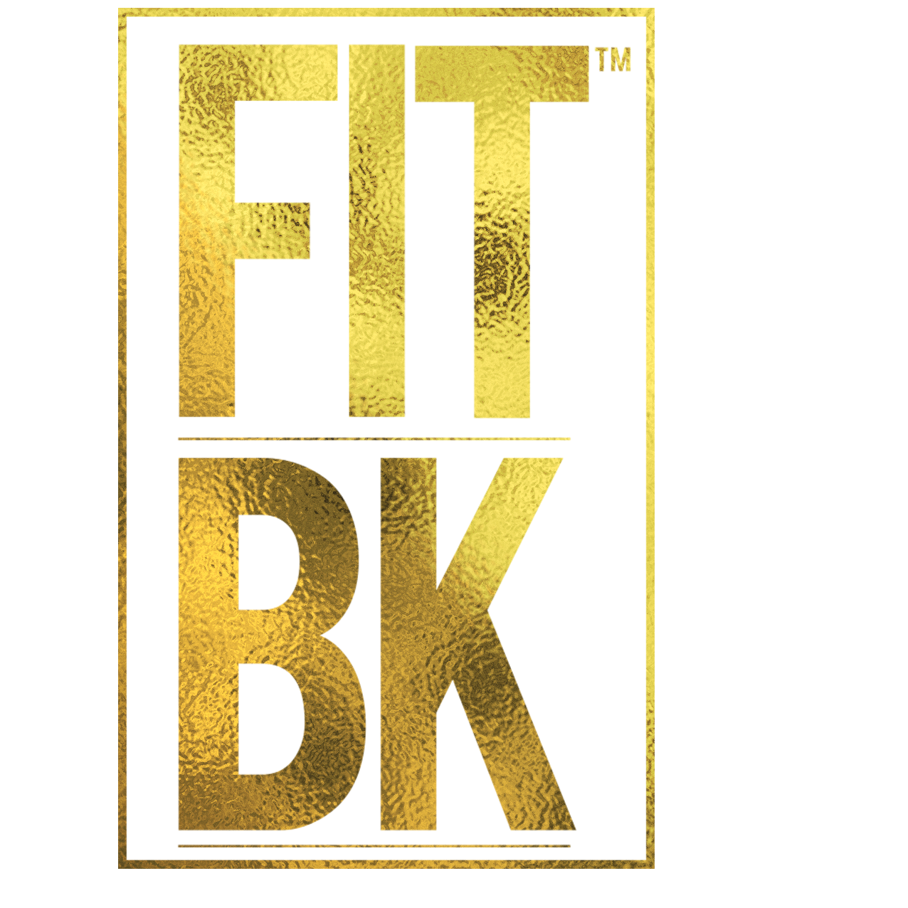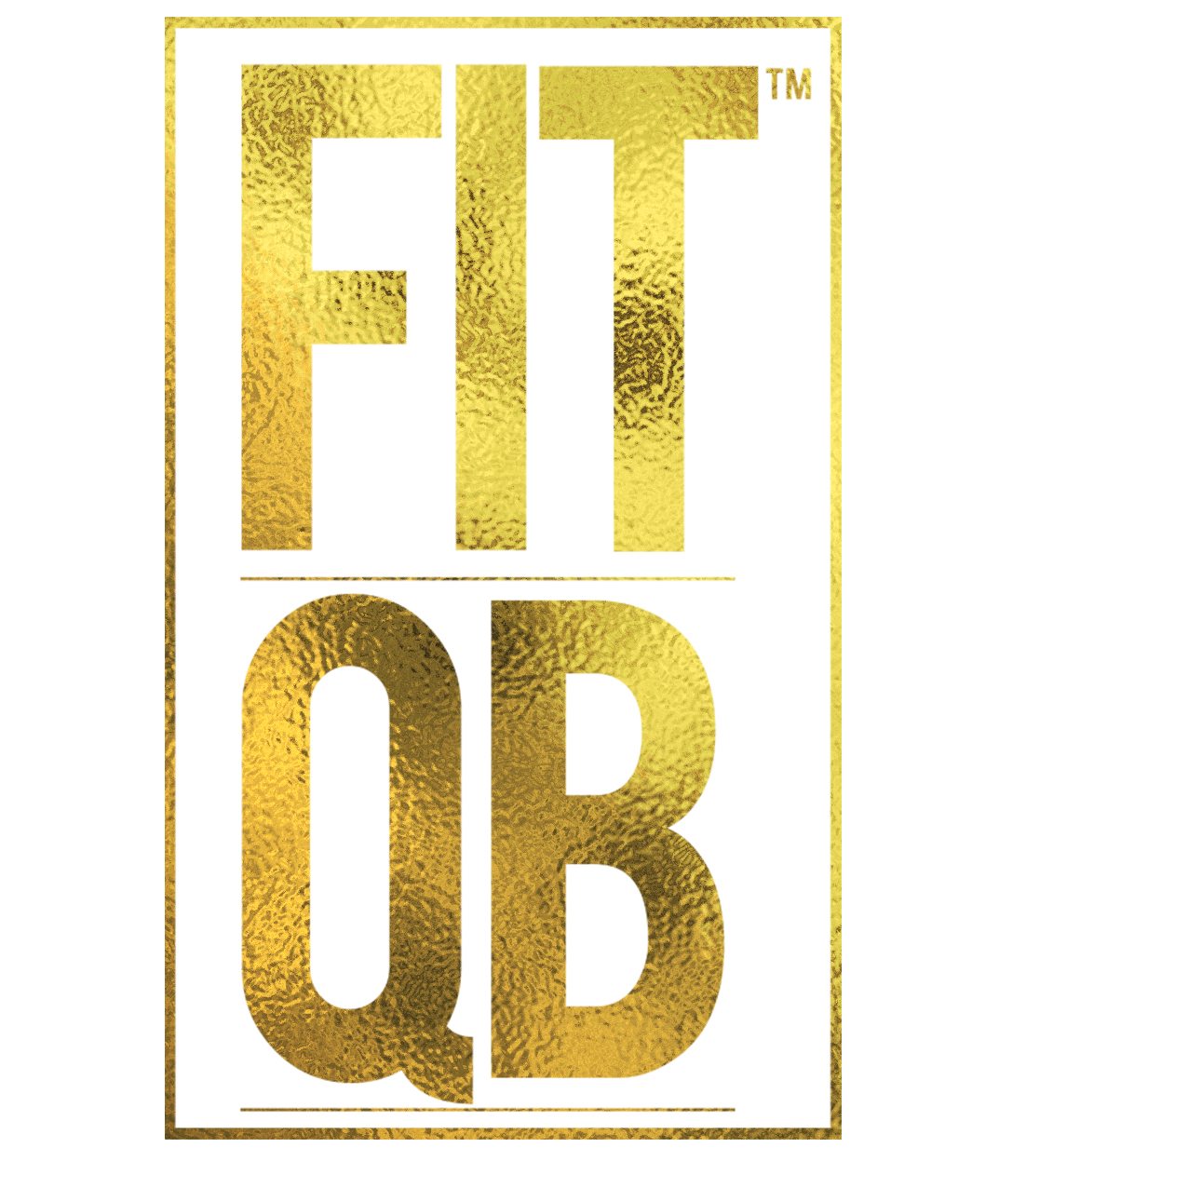

A Free Brooklyn and Queens Borough-Wide
Health and Fitness Initiative Powered by HCC

FITBK™ is a Brooklyn borough-wide health and fitness community initiative created by HCC, Inc. designed to inspire a sense of pride and hope within communities of color who are impacted by the rising racial health disparities such as high rates of diabetes, obesity, heart disease, stress, lack of exercise and poor nutrition. Through free weekly cardio fitness classes infused with international music from the Caribbean and Latin countries, the mission of FITBK™ is to improve the quality of life people of color through ongoing culturally-appropriate physical activity and nutritional programs. FITBK™ currently maintains a database of nearly 15,000 registrants and the program produces nearly 300 events per year. The FITBK™ community fitness program is supported by the Office of Youth and Community Development, NYC Department for the Aging and the New York City Council.
FITBK™ Mission
The mission of the FITBK/FITQB initiative at HCC is to:
- Improve the health and quality of life of our immigrant communities through ongoing culturally-appropriate physical activity and nutritional programs.
- Engage individuals within communities of color who are not participating in physical activity
- Advocate free access to supportive services which addresses mental health issues prevalent among immigrants who are faced with trauma, violence, stress, depression and anxiety
- Create access to free on-site mobile health screenings.
- Develop key partnerships with NYC community resources catering to people of color and immigrants.

The FITBK/FITQB Model and Values
- The FITBK/FITQB program utilizes a team-based model, from our staff to our instructors, representing the population we serve.
- Our free weekly classes incorporate a diverse sense of pride through Caribbean and international music, languages, food, and camaraderie.
- We have an all-inclusive policy where everyone is invited to participate in a safe and fun environment regardless of your class status, background, race, sex, identity or orientation.

“Obesity is the second cause of preventable death in the United States after cigarette smoking,” said Dr. Andre K. Peck, Executive Director of HCC. “Our hope is to see people change their lifestyle from sedentary to a more active one, as well as to make better nutritional choices.”
Quick Facts:
- Officially launched in 2012 as Fitness for Flatbush/F3 with only 15 registrants. Rebranded in 2014 as FITBK and currently maintains a database of over 15,000 registrants to date.
- A recurring 12-month program with weekly attendance ranging from 40-120 participants, and up to 300 for special fitness events.
- 28-41% of adults living in Central Brooklyn neighborhoods are obese, compared to Brooklyn’s 27% obesity rate (and 24% NYC).
- 32% of adults living in Rockaway neighborhoods are obese, compared to Queens’ 22% obesity rate (and 24% NYC).
- The 2nd leading cause of death within communities of color is heart disease from poor nutrition and lack of exercise.

FITBK/FITQB Demographics:
- 80% Individuals of Caribbean Descent
- 15% Individuals of Hispanic Origin
- 4% African-American
- 1% White/Other
Where We Are
-Prospect-Lefferts Gardens -Bedford-Stuyvesant -Coney Island/Luna Park
-Rockaway -Flatbush/East Flatbush -Crown Heights -Sunset Park
-Canarsie/Flatlands -Brooklyn Heights -Brownsville/East New York
FITBK/FITQB Linkage to Additional Services:
- Free weekly fitness classes, including special themed and health awareness classes.
- Ongoing food and nutritional education and counseling via our re-occurring FITBK 90-Day Fitness Challenge on Facebook and Facebook Live.
- Unlimited access and linkage to comprehensive health screenings and supportive social services (such as housing, primary care, benefits, mental health counseling) through HCC.
FITBK™ Past and Present Community Partners: Brooklyn Communities Collaborative, Emblem Health, MetroPlus Health Plan, Essentia Water, Safe Horizon, Simply Protein, Big Apple Urgent Care, VP Records, Mayor’s Office of Immigrant Affairs, Office of the Brooklyn Borough President, NYC Council Member Farah Louis, NYC Council Member Rita Joseph, NYC Council Member Alicka Ampry-Samuel, NYC Council Member Rita Joseph, New York State Senator Kevin S. Parker, New York State Assembly Member Rodneyse Bichotte, New York State Assembly Member Mathylde Frontus, New York State Senator Diane J. Savino, West Indian-American Day Carnival Association, Public Health Solutions, and BRIC TV.

Get Involved with FITBK
Work with HCC to bring free fitness classes to your community by helping us find the space, funding and/or sponsors to support our program. It is through the generous help of our community members and sponsors that we will be able to expand this program. We are open to partnerships and collaborations to help expand our FITBK program. If you think you can help in any way, connect with us via Facebook / Instagram: @officialfitbk or send an email directly to the FITBK team at fitness@hccinc.org

